Name: Umer farooq

CMS: 229143

**Task 1:** Create a database named "mydb". Save the code in a file called "demo_create_mongo_db.js" and run the file.

var MongoClient = require('mongodb').MongoClient;

var url = "mongodb://localhost:27017/mydb";

MongoClient.connect(url, function(err, db) {

if (err) throw err;

console.log("Database created!");

db.close();

})

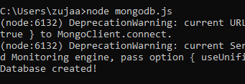

**Task 2:** Create a collection called "customers". Save the code in a file called "demo_mongodb_createcollection.js" and run the file.

var MongoClient = require('mongodb').MongoClient;

var url = "mongodb://localhost:27017/";

MongoClient.connect(url,{ useUnifiedTopology: true }, function(err, db) {

if (err) throw err;

var dbo = db.db("mydb");

dbo.createCollection("customers", function(err, res) {

if (err) throw err;

console.log("Collection created!");

db.close();

});

})

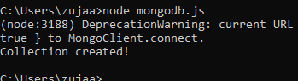

**Task 3: Insert a document in the "customers" collection. Save the code in a file called "demo_mongodb_insert.js" and run the file.**

var MongoClient = require('mongodb').MongoClient;

var url = "mongodb://localhost:27017/";

MongoClient.connect(url, function(err, db) {

if (err) throw err;

var dbo = db.db("mydb");

var myobj = { name: "Company Inc", address: "Highway 37" };

dbo.collection("customers").insertOne(myobj, function(err, res) {

if (err) throw err;

console.log("1 document inserted");

db.close();

});

});

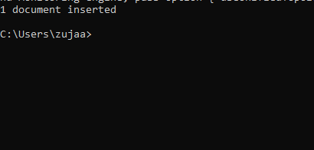

**Task 4: Insert multiple documents in the "customers" collection. Save the code in a file called "demo_mongodb_insert_multiple.js" and run the file.**

var MongoClient = require('mongodb').MongoClient;

var url = "mongodb://localhost:27017/";

MongoClient.connect(url, function(err, db) {

if (err) throw err;

var dbo = db.db("mydb");

var myobj = [

{ name: 'John', address: 'Highway 71'},

{ name: 'Peter', address: 'Lowstreet 4'},

{ name: 'Amy', address: 'Apple st 652'},

{ name: 'Hannah', address: 'Mountain 21'},

{ name: 'Michael', address: 'Valley 345'},

{ name: 'Sandy', address: 'Ocean blvd 2'},

{ name: 'Betty', address: 'Green Grass 1'},

{ name: 'Richard', address: 'Sky st 331'},

{ name: 'Susan', address: 'One way 98'},

{ name: 'Vicky', address: 'Yellow Garden 2'},

{ name: 'Ben', address: 'Park Lane 38'},

{ name: 'William', address: 'Central st 954'},

{ name: 'Chuck', address: 'Main Road 989'},

{ name: 'Viola', address: 'Sideway 1633'}

];

dbo.collection("customers").insertMany(myobj, function(err, res) {

if (err) throw err;

console.log("Number of documents inserted: " + res.insertedCount);

db.close();

});

});

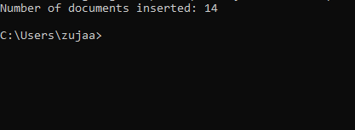

**Task 5: Insert three records in a "products" table, with specified _id fields. Save the code in a file called "demo_mongodb_insert_id.js" and run the file.**

var MongoClient = require('mongodb').MongoClient;  
var url = "mongodb://localhost:27017/";  
  
MongoClient.connect(url, function(err, db) {  
  if (err) throw err;  
  var dbo = db.db("mydb");  
  var myobj = [  
    { **_id: 154**, name: 'Chocolate Heaven'},  
    { **_id: 155**, name: 'Tasty Lemon'},  
    { **_id: 156**, name: 'Vanilla Dream'}  
  ];  
  dbo.collection("products").insertMany(myobj, function(err, res) {  
    if (err) throw err;  
    console.log(res);  
    db.close();  
  });  
});

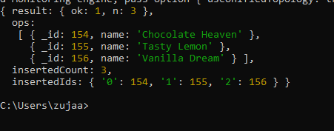

**Task 6: Find the first document in the customer’s collection. Save the code in a file called "demo_mongodb_findone.js" and run the file.**

var MongoClient = require('mongodb').MongoClient;  
var url = "mongodb://localhost:27017/";  
  
MongoClient.connect(url, function(err, db) {  
  if (err) throw err;  
  var dbo = db.db("mydb");  
  dbo.collection("customers").findOne({}, function(err, result) {  
    if (err) throw err;  
    console.log(result.name);  
    db.close();  
  });  
});

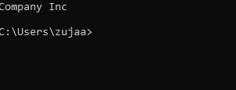

**Task 7: Return the fields "name" and "address" of all documents in the customers collection**

var MongoClient = require('mongodb').MongoClient;  
var url = "mongodb://localhost:27017/";  
  
MongoClient.connect(url, function(err, db) {  
  if (err) throw err;  
  var dbo = db.db("mydb");  
  dbo.collection("customers").find({}, **{ projection: { _id:** 0**, name:** 1**, address:** 1 **} }**).toArray(function(err, result) {  
    if (err) throw err;  
    console.log(result);  
    db.close();  
  });  
});

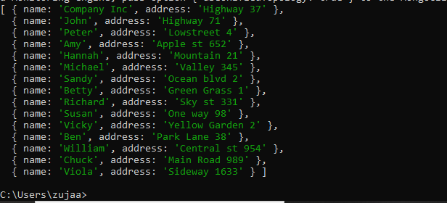

**Task 8: Find documents with the address "Park Lane 38". Save the code in a file called "demo_mongodb_query.js" and run the file.**

var MongoClient = require('mongodb').MongoClient;  
var url = "mongodb://localhost:27017/";  
  
MongoClient.connect(url, function(err, db) {  
  if (err) throw err;  
  var dbo = db.db("mydb");  
var **query = { address:** "Park Lane 38" **};**  dbo.collection("customers").find(**query**).toArray(function(err, result) {  
    if (err) throw err;  
    console.log(result);  
    db.close();  
  });  
})

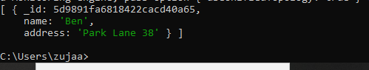

**Task 9: Sort the result alphabetically by name. Save the code in a file called "demo_sort.js" and run the file.**

var MongoClient = require('mongodb').MongoClient;  
var url = "mongodb://localhost:27017/";  
  
MongoClient.connect(url, function(err, db) {  
  if (err) throw err;  
  var dbo = db.db("mydb");  
var **mysort = { name:** 1 **};**  dbo.collection("customers").find()**.**sort**(mysort)**.toArray(function(err, result) {  
    if (err) throw err;  
    console.log(result);  
    db.close();  
  });  
});

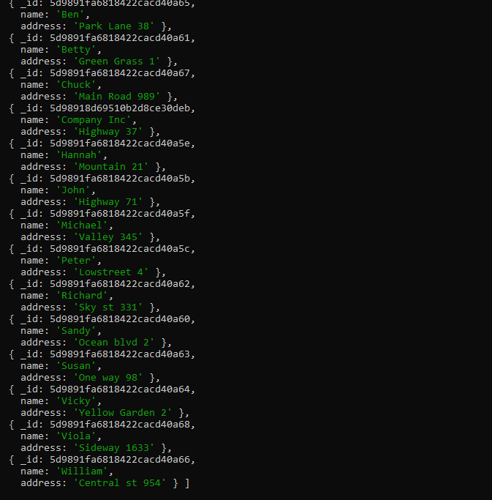

**Task 10: Delete the document with the address "Mountain 21". Save the code in a file called "demo_delete.js" and run the file.**

var MongoClient = require('mongodb').MongoClient;  
var url = "mongodb://localhost:27017/";  
  
MongoClient.connect(url, function(err, db) {  
  if (err) throw err;  
  var dbo = db.db("mydb");  
var **myquery = { address:** 'Mountain 21' **};**  dbo.collection("customers").deleteOne(myquery, function(err, obj) {  
    if (err) throw err;  
    console.log("1 document deleted");  
    db.close();  
  });  
});



**Task 11: Delete all documents were the address starts with the letter "O". Save the code in a file called "demo_delete_many.js" and run the file**

var MongoClient = require('mongodb').MongoClient;  
var url = "mongodb://localhost:27017/";  
  
MongoClient.connect(url, function(err, db) {  
  if (err) throw err;  
  var dbo = db.db("mydb");  
var **myquery = { address: /^O/ };**  dbo.collection("customers").deleteMany(myquery, function(err, obj) {  
    if (err) throw err;  
    console.log(obj.result.n + " document(s) deleted");  
    db.close();  
  });  
});

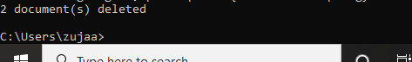

**Task 12: Delete the "customers" table. Save the code in a file called "demo_drop.js" and run the file.**

var MongoClient = require('mongodb').MongoClient;  
var url = "mongodb://localhost:27017/";  
  
MongoClient.connect(url, function(err, db) {  
  if (err) throw err;  
  var dbo = db.db("mydb");  
  dbo.collection("customers").drop(function(err, delOK) {  
    if (err) throw err;  
    if (delOK) console.log("Collection deleted");  
    db.close();  
  });  
});



**Task 13: Update the document with the address "Valley 345" to name="Mickey" and address="Canyon 123". Save the code in a file called "demo_update_one.js" and run the file**

var MongoClient = require('mongodb').MongoClient;  
var url = "mongodb://127.0.0.1:27017/";  
  
MongoClient.connect(url, function(err, db) {  
  if (err) throw err;  
  var dbo = db.db("mydb");  
  var myquery = { address: "Valley 345" };  
  var newvalues = { $set: {name: "Mickey", address: "Canyon 123" } };  
  dbo.collection("customers").updateOne(myquery, newvalues, function(err, res) {  
    if (err) throw err;  
    console.log("1 document updated");  
    db.close();  
  });  
});

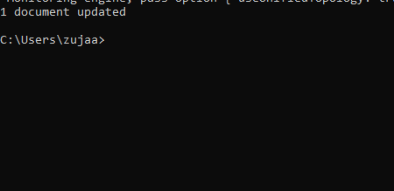

**Task 14: Consider you have a "customers" collection. Limit the result to only return 5 documents. Save the code above in a file called "demo_mongodb_limit.js" and run the file.**

var MongoClient = require('mongodb').MongoClient;  
var url = "mongodb://localhost:27017/";  
  
MongoClient.connect(url, function(err, db) {  
  if (err) throw err;  
  var dbo = db.db("mydb");  
  dbo.collection("customers").find()**.**limit**(**5**)**.toArray(function(err, result) {  
    if (err) throw err;  
    console.log(result);  
    db.close();  
  });  
});

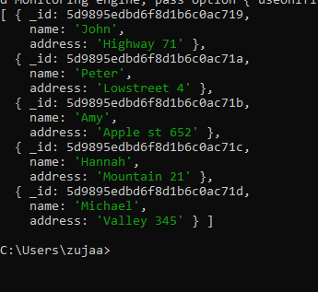

**Task 15: Practice the Join operations on different tables.**

var MongoClient = require('mongodb').MongoClient;

var url = "mongodb://127.0.0.1:27017/";

MongoClient.connect(url, function(err, db) {

if (err) throw err;

var dbo = db.db("mydb");

dbo.collection('orders').aggregate([

{ $lookup:

{

from: 'products',

localField: 'product_id',

foreignField: '_id',

as: 'orderdetails'

}

}

]).toArray(function(err, res) {

if (err) throw err;

console.log(JSON.stringify(res));

db.close();

});

});